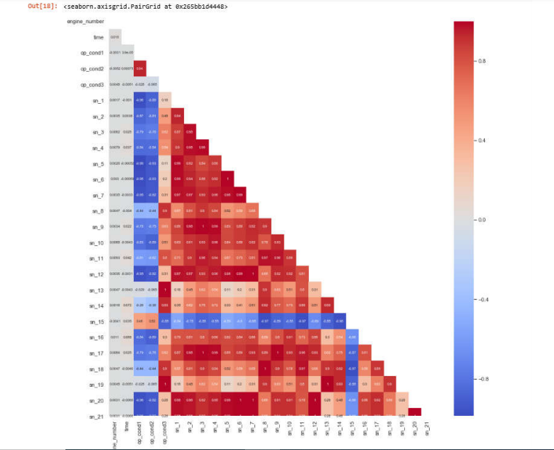

⮚ Heatmap, a very useful visualization tool, generally shows the correlation between  
features.

⮚ The red colored boxes indicate that the correlation is intense. We can see that there are  
many features that have positive correlation in general.

⮚ Light colored (eg white colored) boxes represent low correlation.

⮚ For example, the value between sn_9 and sn_3 sensors is 1. This represents a complete  
positive correlation between these sensors.

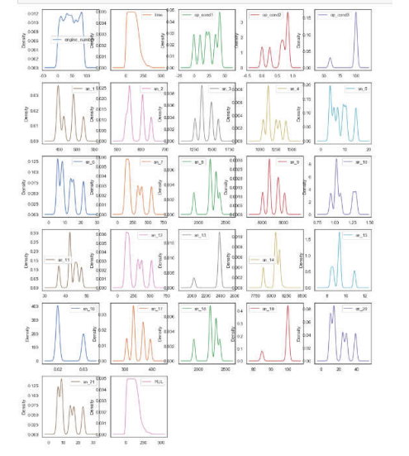

⮚ This visualization tool also shows the general distribution of each features.

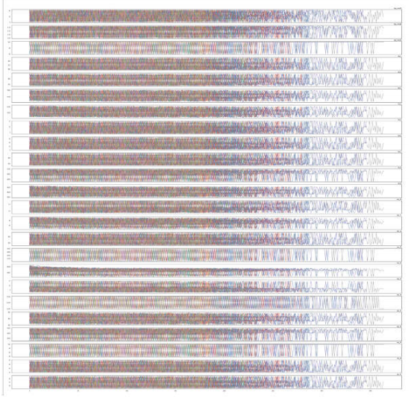

⮚ If we look at the general distribution of the feature values, it can be seen that the change depending on the specific motors is very intense in each feature. It seems difficult to find a general trend.

⮚ But it seems a little more likely that we are able to find a specific trend for sn_8, sn_11, sn_14, sn_15 and sn_18 sensors.